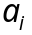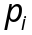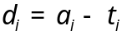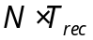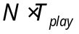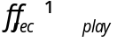
packet
Sample-in
Packet
Sender
Receiver
Packet
Play-out
Sample-out
N
samples
N
samples
Figure 1 – Single Packet View in Independent observer’s timeframe (“absolute time”)

Clock Skew – Difference in sample periods at recorder and player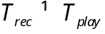.
Delay 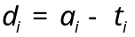 includes both clock skew and variable network delay. 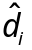= average delay.
Jitter – varying inter-packet delay, i.e. dispersion of 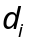 around .

Figure 2 – Compound View in Independent observer’s timeframe (“absolute time”)

This is complicated view that can be simplified by spreading elements in 2D:
- per process (sampling, sending, receiving, etc.), or
- per packet (tracking single packet by its sequence number or timestamp)

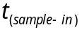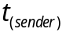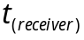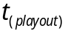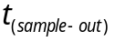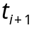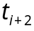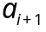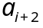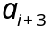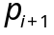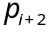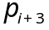
Figure 3 – Per Process View in Independent observer’s timeframe (“absolute time”)

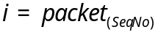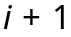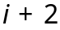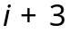
Figure 4 – Per Packet View in Independent observer’s timeframe (“absolute time”)

If we fix 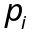 (that is synchronous to sample play-out clock), than we get much simpler view to track jitter.
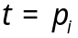
Lost Packets
q^{th} Quantile
Mean Value
q
PDF
CDF
Clock Skew
Figure 5 – Per Packet View in Play-out process’ timeframe

Clock skew is visible as slow, constant and linear variation in time of delay average .
Play-out buffer depth constant is set by the user requiring certain maximum lost packet percentage.
It is adjusted by the system to be as minimum as possible, depending on the current distribution of the network delay and clock skew.
Real-time statistics of the distribution is monitored by the system: population mean (average) and variance (i.e. standard deviation) of the delay.

